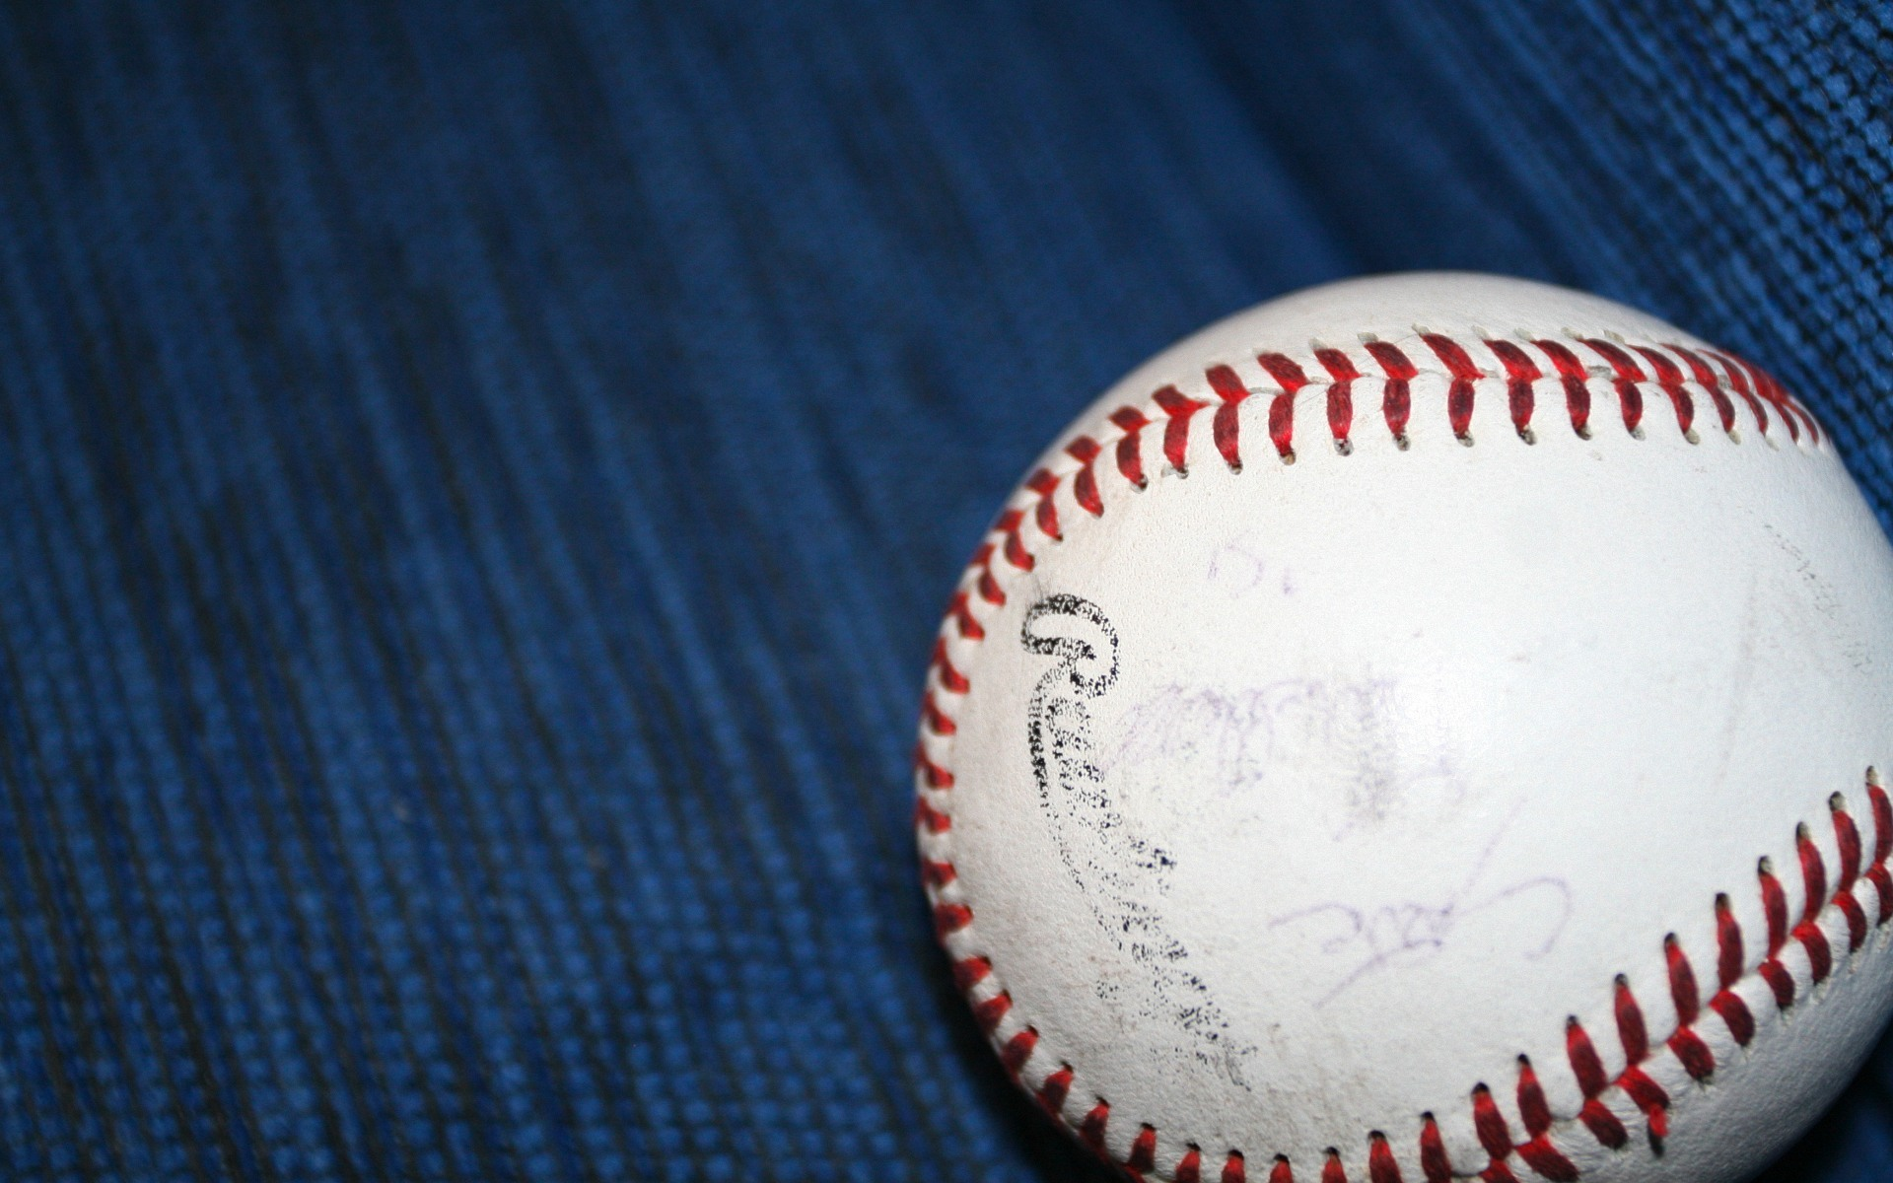

**CROYDON BASEBALL CLUB**

**CROYDON BASEBALL CLUB**

**Help us celebrate 50 years of Croydon Rams Baseball as we catch up with old friends & take a look back at half a century of the club**

**Saturday 2nd of August 2014**

**Commencing at 2:40 during the 1st’s Game against Forest Hill at**

**Barngeong Reserve, Croydon**

**(Bambra Street, Croydon)**

**Finger Food Provided**

**Drinks at reduced prices**

